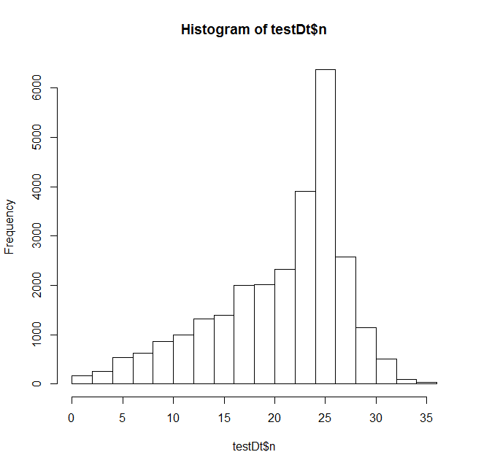

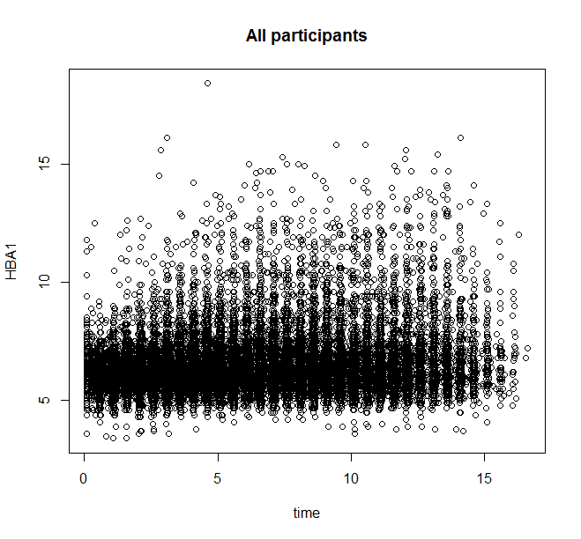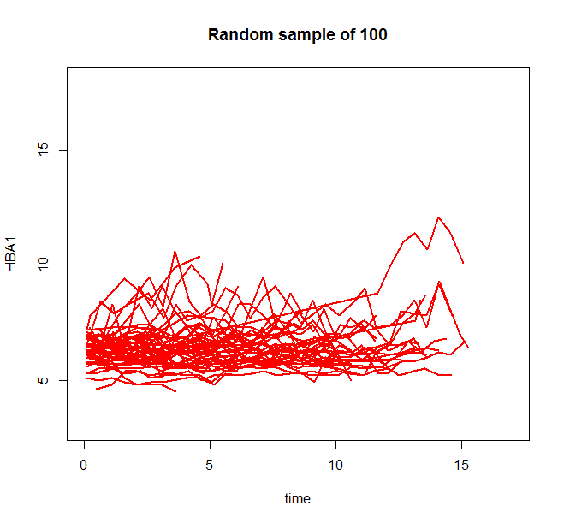

Model 1: HBA1~spline(diabyr, degree=2, knots=c(2))

Speeed~ age_d, bmi_d, hba1_d+trt

Error in MEestimate(nlmeSt, grpShrunk) :

Singularity in backsolve at level 0, block 1

In addition: Warning messages:

1: In nlme.formula(HBA1 ~ d2k1_model(time = time, beta0, beta1, beta2, :

Iteration 1, LME step: nlminb() did not converge (code = 1). PORT message: false convergence (8)

2: In nlme.formula(HBA1 ~ d2k1_model(time = time, beta0, beta1, beta2, :

Iteration 2, LME step: nlminb() did not converge (code = 1). Do increase 'msMaxIter'!

3: In nlme.formula(HBA1 ~ d2k1_model(time = time, beta0, beta1, beta2, :

Iteration 3, LME step: nlminb() did not converge (code = 1). Do increase 'msMaxIter'!

Model 2: HBA1~spline(diabyr, degree=3, knots=c(2))

Speeed~ age_d, bmi_d, hba1_d+trt

Error in nlme.formula(HBA1 ~ d3k1_model(time = time, beta0, beta1, beta2, :

Singularity in backsolve at level 0, block 1

Model 3 ;: HBA1~spline(diabyr, degree=3, knots=c(2))

Speeed~ 1

Error in nlme.formula(HBA1 ~ d2k1_model(time = time, beta0, beta1, beta2, :

Singularity in backsolve at level 0, block 1

In addition: Warning messages:

1: In nlme.formula(HBA1 ~ d2k1_model(time = time, beta0, beta1, beta2, :

Singular precision matrix in level -1, block 4

2: In nlme.formula(HBA1 ~ d2k1_model(time = time, beta0, beta1, beta2, :

Singular precision matrix in level -1, block 4

3: In nlme.formula(HBA1 ~ d2k1_model(time = time, beta0, beta1, beta2, :

Singular precision matrix in level -1, block 4

4: In nlme.formula(HBA1 ~ d2k1_model(time = time, beta0, beta1, beta2, :

Singular precision matrix in level -1, block 4

5: In nlme.formula(HBA1 ~ d2k1_model(time = time, beta0, beta1, beta2, :

Iteration 3, LME step: nlminb() did not converge (code = 1). PORT message: false convergence (8)